### Miniature House #7 - Origami Roof with a Porch

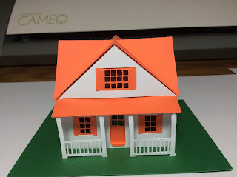

This house is the same as the previous house but with an added porch. I recommend making the porch and attach it to the house first. Insert the columns into the base and then construct the house around the base. Glue the roof on last. I used glue dots in the corners of the house because I am impatient and can't wait for the glue to dry.  
  
I used card stock to make this house.